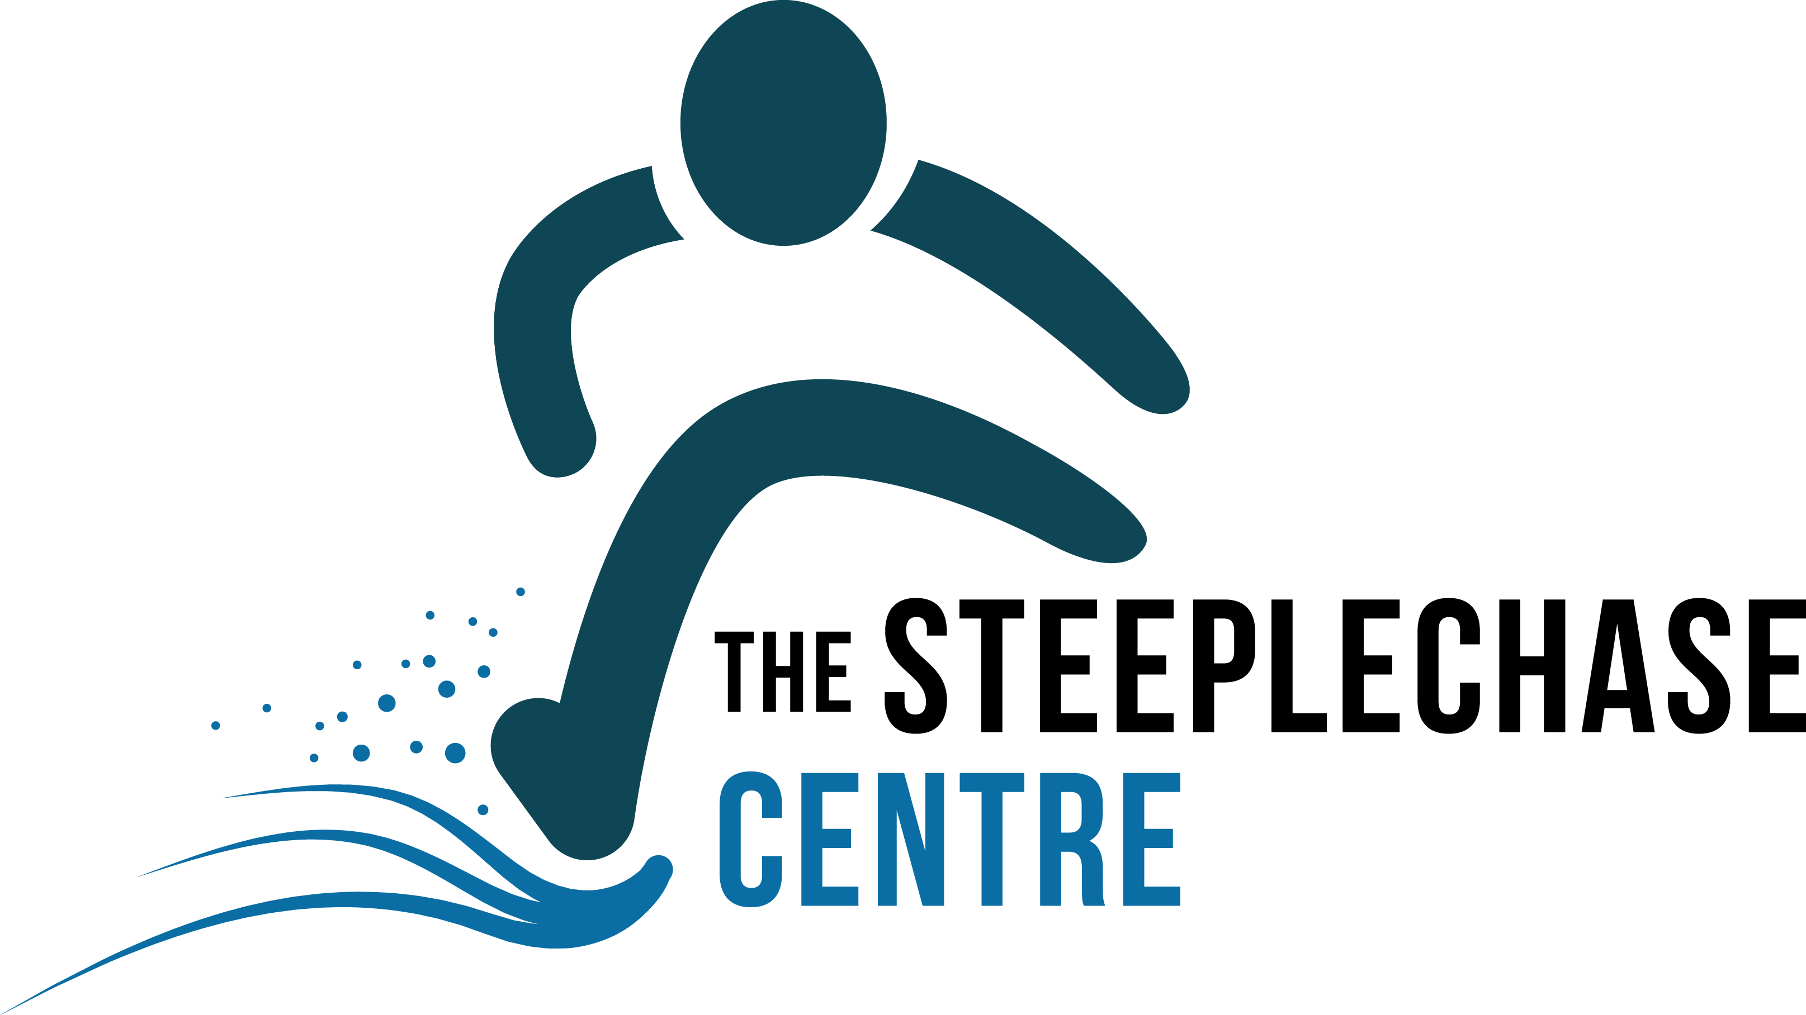

Steeplechase Festival
1st May 2022

West Suffolk Arena
Bury St. Edmunds Leisure Centre
Beetons Way, BURY ST. EDMUNDS IP33 3TT

Steeplechase races:

1500M U15G / U17W / U20W / SW
2000M U17W / U20W /SW
3000M SW

1500M U15B / U17M / V60M
2000M U17M / U20M / SM
3000M SM

Also: 800m all age groups U13-Senior
1500m all age groups U13-Senior

Entry fee: £10 per race
Entries online at:
Steeplechase Festival (opentrack.run)

UKA Event Licence number: Pending

For further information please contact David Cripps
Email: david.cripps7@outlook.com Tel:07484811982

